#### **DRESUME**

**by**

**Yash Gupta (2200320140198)**

#### Under the guidance of

##### Mr. Asheesh Pandey

##### (Assistant Professor)(Sr. Scale)

**Department of Computer Applications**

|  |
| --- |
|  |

**ABES Engineering College**

**19th Km Stone, NH-09, Ghaziabad (U.P)**

**July, 2024**

**DRESUME**

**by**

**Yash Gupta (2200320140198)**

**Submitted to the Department of Computer Applications**

**in partial fulfillment of the requirements**

**for the degree of**

**Master of Computer Application**

#### Under the guidance of

##### Mr. Asheesh Pandey

##### (Assistant Professor) (Sr.Scale)

**Department of Computer Applications**

|  |
| --- |
|  |

**ABES Engineering College**

**19th Km Stone, NH-09, Ghaziabad (U.P)**

**July, 2024**

**DECLARATION**

I hereby declare that the work being presented in this report entitled “**dResume**” is an authentic record of my work carried out under the supervision of “**Mr. Asheesh Pandey**”

The matter embodied in this report has not been submitted by me for the award of any other degree.

**Date: Signature of students(s)**

**Yash Gupta**

**Dept.: Computer Applications**

This is to certify that the above statement made by the candidate is correct to the best of my knowledge.

**Signature of HOD Signature of Supervisor**

**Prof. (Dr.) Devendra Kumar Mr. Asheesh Pandey**

**HOD-MCA Assistant Professor**

**(Sr. Scale)**

**Dept.:-Computer Applications**

**Date:**

**CERTIFICATE**

This is to certify that Project Report entitled **“dResume”** which is submitted by **Yash Gupta** in partial fulfillment of the requirement for the award of degree **Master of Computer Application** in Department of Computer Applications of **Dr. A.P.J. Abdul Kalam Technical University,** is a record of the candidate’s own work carried out by him/them under my supervision.

The matter embodied in this Major Project Report is original and has not been submitted for the award of any other degree.

The plagiarism percentage evaluated for the content presented is

**Supervisor Signature**

**Mr. Asheesh Pandey**

**Assistant Professor**

**(Sr. Scale)**

**Date:**

## ACKNOWLEDGEMENT

Introducing the report on the MCA project finished during MCA Final Year fills me with incredible happiness. I owe an exceptional obligation of appreciation to **Mr. Asheesh Pandey (Assistant Professor)** **Department of Computer Applications, ABESEC, Ghaziabad** for his/her constant support and guidance throughout the course of our work. His /Her sincerity, thoroughness, and perseverance have been a constant source of inspiration for me. It is just his perceptive endeavors that our undertakings have come around.

I also take the opportunity to recognize the contribution of **Prof. (Dr.) Devendra Kumar Head, Department of Computer Applications, ABESEC, Ghaziabad** for his support and assistance during the development of the project.

I also don't want to miss the opportunity to thank the entire department's faculty members for their helpful support and cooperation during the project's development. Last but not least, we want to thank our friends for their help in getting the project done.

**Signature of Student(s)**

**Yash Gupta**

**2200320140198**

## ABSTRACT

The current system creates resumes manually either using Word or Google doc, so there are some issues with the current system. The existing system suffered from a number of shortcomings. Since the entire system had to be maintained, the process of storing, maintaining and retrieving information was very tedious and time-consuming. The records were never in a systematic order, there used to be a lot of difficulty in assigning any particular transaction to a particular context. If any information was to be found, it was required to go through various registers, the documents would never exist. something like report generation There would always be wasted time entering records and retrieving records Another problem was that it was very difficult to find errors in entering records Once the records were inserted it was very difficult to update those records.

|  |  |  |  |
| --- | --- | --- | --- |
| **S.NO.** | **TABLE OF CONTENTS** | | **PAGE NO.** |
|  | DECLARATION | | iv |
|  | CERTIFICATE | | v |
|  | ACKNOWLEDGEMENT | | vi |
|  | ABSTRACT | | vii |
|  | TABLE OF CONTENT | | viii |
|  | LIST OF TABLES | | x |
|  | LIST OF FIGURES | | xi |
|  | LIST OF SYMBOLS | | xii |
|  | LIST OF ABBREVIATIONS | | xiii |
| Chapter 1: | Introduction | | 1 |
|  | 1.1 | Problem Definition / Statement | 1 |
|  | 1.2 | Objective / Project Objective | 2 |
|  | 1.3 | Scope Of Project | 8 |
|  | 1.4 | Need | 9 |
| Chapter 2 | Literature Review | | 10 |
| Chapter 3 | Feasibility Study | | 11 |
|  | 3.1 | Purpose | 11 |
|  | 3.2 | Scope | 13 |
| Chapter 4 | System Requirements | | 14 |
|  | 4.1 | Functional Requirement | 14 |
|  | 4.2 | Non- Functional Requirement | 14 |
|  | 4.3 | Hardware Requirement | 15 |
|  | 4.4 | Software Requirement | 15 |
|  | 4.5 | Use Cases | 16 |
| Chapter 5 | System Design | | 17 |
|  | 5.2 | Data Flow Diagram(DFD) | 17 |
|  | 5.3 | Entity-Relationship Diagrams | 18 |
|  | 5.4 | Class Diagrams | 19 |
|  | 5.5 | Sequence Diagrams | 20 |
|  | 5.6 | Activity Diagram | 21 |
| Chapter 6 | GUI / Coding | | 22 |
| Chapter 7 | Testing(Test Plan/Cases/Result) | | 23 |
| Chapter 8: | Conclusion | | 24 |
|  | 8.1 | Project Limitation | 24 |
|  | 8.2 | Future Scope | 25 |
| Chapter 9 | References | | 26 |
|  | Appendices (Plagiarism Report) | |  |

**LIST OF TABLES**

|  |  |  |
| --- | --- | --- |
| **S. No.** | **Topics** | **Page No.** |
| Table-1 | Timeline of Project | 49 |
| Table -2 | Gantt Chart | 50 |

## LIST OF FIGURES

|  |  |  |
| --- | --- | --- |
| **S. No.** | **Topic** | **Page No.** |
| Figure-1 | MVC Diagram | 12 |
| Figure-2 | ER-Diagram | 13 |
| Figure-3 | 0 level DFD | 14 |
| Figure-4 | 1st level DFD | 15 |
| Figure-4 | Use Case Diagram | 16 |
| Figure-5 | Class Diagram | 17 |
| Figure-6 | Deployment Diagram | 18 |

**LIST OF SYMBOLS**

|  |  |
| --- | --- |
| * | Multiplication Symbol |
| ≠ | Not Equal |
| < | Smaller than |

**LIST OF ABBREVIATIONS**

|  |  |
| --- | --- |
| AWS | Amazon Web Service |
| S3 | Simple Storage Service |
| RDS | Relational Database Service |
| IAM | Identity and Access Management |
| EC2 | Elastic Compute Cloud |

# **CHAPTER 1**

# **INTRODUCTION**

### 1.1 PROBLEM DEFINITION

A resume is the first meeting between you and a potential employer, more often than ever. So how do you want to be remembered? Wrinkled and messy. Neat and structured. Long and boring. Accurate and interesting. Companies do not have time to interview every applicant who is interested in the job. If they did, there would be no company to work for. They use a process of elimination. That's right - he continues. When a job seeker wants to apply for a job online, they generally need to attach their resume to an email. The online resume builder system provides users with popular resume formats and a better way to showcase their resumes to employers. A job seeker does not need to attach a resume to every email, just provide the URL of your resume and the employer can view the resume online by clicking on the link and also download it.

### 

### 1.2 **OBJECTIVE**

The Objectives of Online Resume Builder are -

**Simplify the resume creation process:** Provide a user-friendly interface to create a professional-looking resume in a short amount of time.

**Offer customization options:** Allow users to tailor their resume to specific job openings or industries by providing a range of templates, formatting options, and content suggestions.

**Improve job search efficiency:** Help users create a strong, attention-grabbing resume that increases their chances of getting noticed by potential employers and recruiters.

**Enhance job search visibility:** Assist users in creating a resume that is optimized for applicant tracking systems (ATS) and search engines, making it more likely to appear in search results.

**Save time and effort:** Automate the resume creation process, allowing users to focus on other aspects of their job search, such as networking and interviewing.

**Improve user experience:** Make the resume creation process enjoyable and engaging, with features such as drag-and-drop interfaces, real-time feedback, and easy editing capabilities.

**1.3** **SCOPE OF PROJECT**

Online Resume Builder can be used in accordance with customer requirements. Customers can customize theirs resumes with a selection of topics and details. Services are It's hard to be beaten by competitors because the system is giving customers exactly what they want.

### 1.4 NEED

The current system creates resumes manually using either Word or Google doc, so there are some issues with the current system. The existing system suffered from a number of shortcomings. Since the entire system had to be maintained, the process of storing, maintaining and retrieving information was very tedious and time-consuming. The records were never in a systematic order, there used to be a lot of difficulty in assigning any particular transaction to a particular context. If any information was to be found, it was required to go through various registers, the documents would never exist. something like generating reports There would always be wasted time entering records and retrieving records Another problem was that it was very difficult to find errors in entering records Once the records were entered it was very difficult to update those records.

### 

### 

### **CHAPTER 2**

### LITERATURE REVIEW

### 

### A. Manual Creation of Resume

### Long Back resumes were created manually by using MS Word and the format at that time was quite different. These are the fields that applicants used to mention in their resumes, in personal information applicants used to write their name, address and phone number. Applicants also used to mention their personal opinion in their resume. That time applicants used to mention their both early and recent education details. Applicants used to create either too short or too long resumes because at that time there were no standards set for ideal length of resumes.

### 

### B. Inference Drawn From Conclusion

### Some inferences are drawn from literature review and research regarding what should be the length of a resume? What information should be included in a resume? What information should be avoided while writing a resume? Ideally in personal information name, address, phone number, email address should be included and height, weight, religion, birth date, marital status should be avoided. Resumes of one page length are preferred more over resumes of two page length.

### 

### 

### **CHAPTER** 3

### FEASIBILITY STUDY

**3.1 Purpose**

The feasibility study serves as a critical assessment tool to determine the viability

and potential success of DRESUME. By evaluating various aspects of the project,

including technical, economic, and operational factors, the study aims to provide

insights into the feasibility of developing and implementing the platform. The key

purposes of the feasibility study are as follows:

Understanding Objectives: The study seeks to gain a comprehensive understanding

of DRESUME's objectives, including its intended functionalities, target users, and

expected outcomes. By clarifying the project's goals, the feasibility study sets the

foundation for subsequent assessments.

Assessing Potential Challenges: Identifying potential challenges and obstacles that

may arise during the development and deployment of DRESME is crucial. This

includes technical complexities, market competition, regulatory compliance issues,

and resource constraints. By anticipating these challenges early on, the feasibility

study enables stakeholders to devise strategies to mitigate risks effectively.

Evaluating Expected Outcomes: The feasibility study aims to evaluate the expected

outcomes and benefits of DRESUME upon its successful implementation. This

involves assessing the potential impact on users, such as improved access to

housing options, enhanced user experience, and increased efficiency in the

accommodation search process.

**3.2 Scope**

The feasibility study encompasses a comprehensive assessment of various factors

to determine the feasibility of DRESUME. It covers the following key areas:

**Technical Feasibility:** Technical feasibility is concerned with the availability of hardware and software required for the development of the system, to see compatibility and maturity of the technology proposed to be used and to see the availability of the required technical manpower to develop the system. After the study we came to conclusion that we proceed further with the tools and development environment chosen by us. This was important in our case as we were working on two various phases of the department that will need to be integrated in future to make an extended system.

**Economic Feasibility:** Economic feasibility involves estimating the costs associated

with developing, deploying, and maintaining the DRESUME platform. This includes

expenses related to software development, infrastructure setup, marketing, staffing,

and ongoing operational costs. The study also considers potential revenue streams,

such as subscription fees, advertisements, or transaction commissions, to determine

the platform's financial viability. By comparing the projected costs and benefits,

stakeholders can assess the economic feasibility of DRESUME and make informed

decisions regarding investment.

**Operational Feasibility:** Operational feasibility focuses on evaluating whether

DRESUME can be successfully operated and maintained in the long term. It considers

factors such as user acceptance, usability, support requirements, regulatory

compliance, and scalability. The study assesses the platform's ability to meet user

needs effectively, handle increasing user loads, and adapt to evolving market

conditions. By addressing operational considerations upfront, stakeholders can

ensure that DRESUME remains sustainable and competitive in the long run.

#### CHAPTER 4

#### SYSTEM REQUIREMENTS

#### **4.1 FUNCTIONAL REQUIREMENTS**

**User Registration and Authentication:**

* Users should be able to create accounts with a valid Username and password.
* Secure authentication mechanisms should be implemented to protect user accounts.

**Portfolio:**

* Users can add and view their reviews.

**Blog**:

* Users can create and edit their blog posts.

**Contact:**

* Users can contact the person by filling out the contact form.

**Key Skills:**

* User can showcase their key skills and edit them.

**Coding Skills:**

* User can show and edit their coding skills.

#### **4.2 NON – FUNCTIONAL REQUIREMENTS**

**Performance:**

* A website should serve a specified number of concurrent users without degrading performance.

**Security:**

* User data must be stored securely.

**Usability:**

* Websites should have an intuitive and responsive design for a positive user experience.

**4.3 Hardware Requirements**

The hardware requirements specify the minimum hardware specifications that the

server hosting the DRESUME platform should meet to ensure optimal performance.

These requirements include:

Minimum 8GB RAM to ensure sufficient memory for handling user requests and

database operations.

500GB Hard Disk to accommodate the storage of property listings, user data, and

other platform-related files.

Intel Core i5 Processor or equivalent to provide adequate processing power for

handling concurrent user requests and maintaining system responsiveness.

**4.4 Software Requirements**

The software requirements outline the necessary software components and

technologies that the DRESUME platform relies on for its development and operation.

These requirements include:

Operating System: DRESUME should be compatible with popular operating systems

such as Windows, macOS, and Linux to ensure broad accessibility for users.

Backend: The backend of the platform should be built using Node.js and Express.js,

which provide a robust and scalable framework for developing server-side

applications.

Frontend: The frontend of DRESUME should be developed using React.js, a powerful

JavaScript library for building dynamic user interfaces.

Database: MongoDB, a NoSQL database, should be used to store property listings,

user profiles, and other platform-related data due to its flexibility and scalability.

Other Tools: Redux should be used for state management, while JWT (JSON Web

Tokens) should be employed for user authentication to ensure secure and reliable

user authentication and authorization mechanisms.

**4.5 USE CASES**

**User Registration and Authentication:**

* Users should be able to create accounts with a valid Username and password.
* Secure authentication mechanisms should be implemented to protect user accounts.

**Portfolio:**

* Users can add and show their Reviews..

**Blog**:

* Users can create and edit their blog posts.

**Contact:**

* Users can contact the person by filling out the contact form.

**Key Skills:**

* User can showcase their key skills and edit them.

**Coding Skills:**

* User can show and edit their coding skills.

**Performance:**

* A website should serve a specified number of concurrent users without degrading performance.

**Security:**

* User Details must be stored Safely.

**Usability:**

* The website should have an intuitive and responsive design for a positive user experience.

**CHAPTER 5**

**SYSTEM DESIGN**

**5.2 DATA FLOW DIAGRAM(DFD)**

**Zero Level DFD**

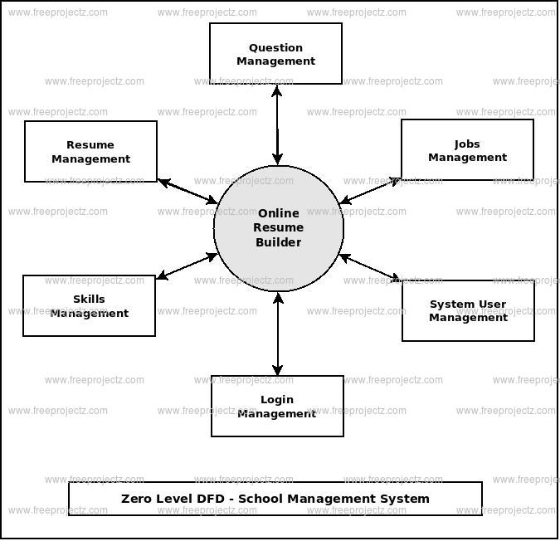

**First Level DFD**

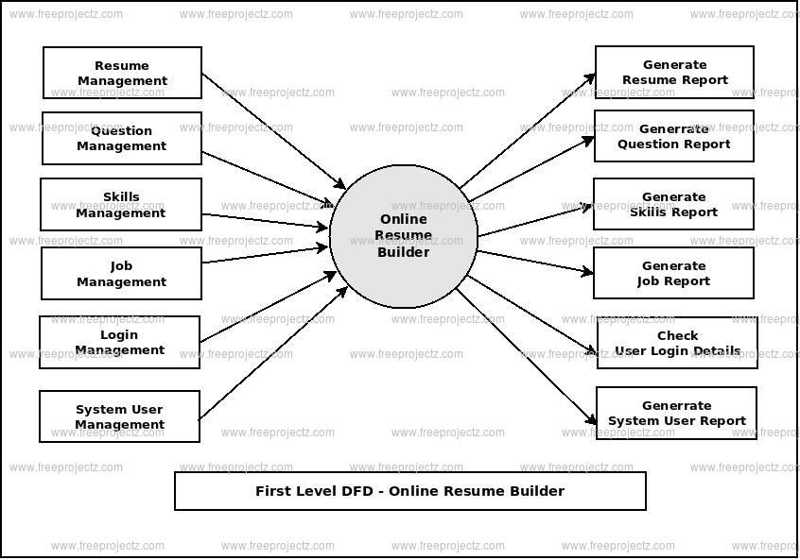

### 5.3 ER-DIAGRAM

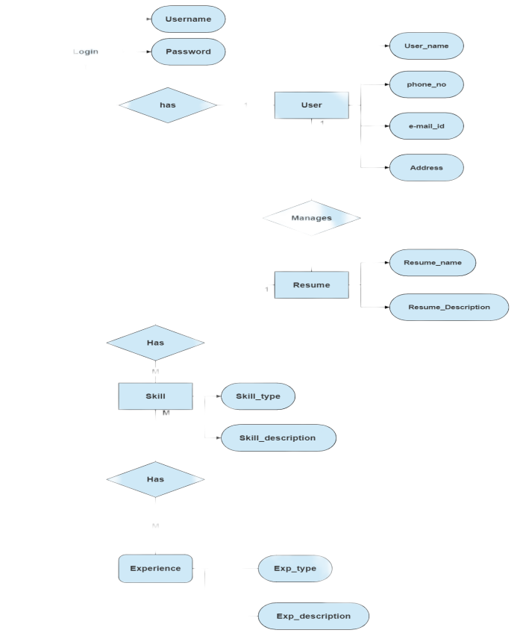

**5.4 CLASS DIAGRAM**

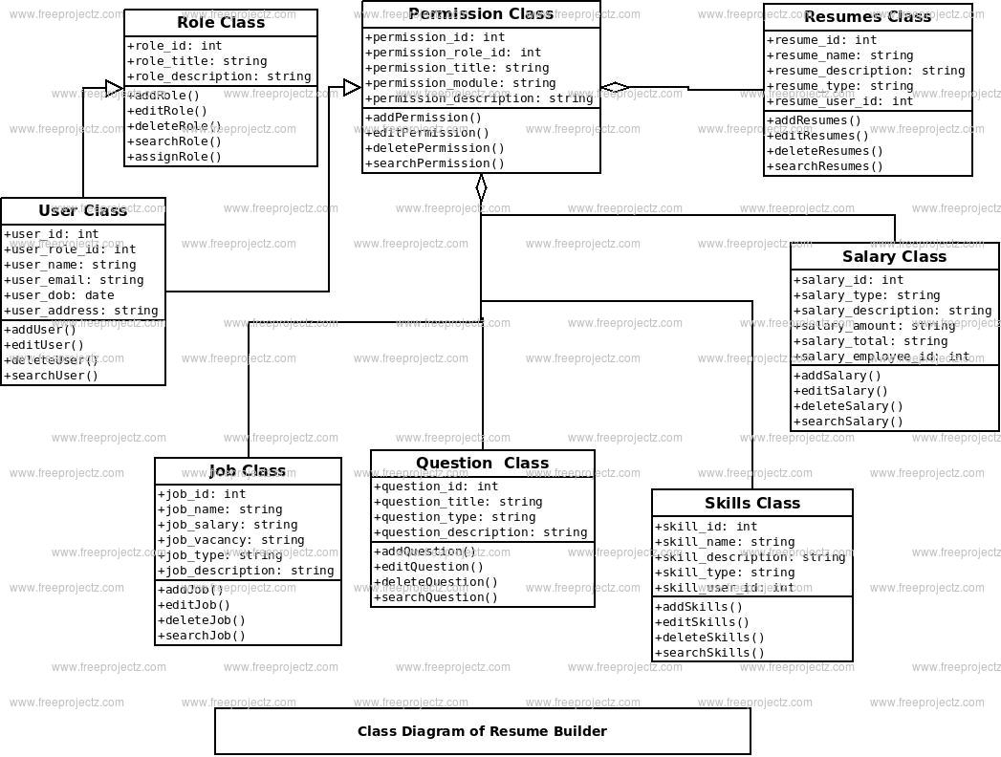

**5.5 SEQUENCE DIAGRAM**

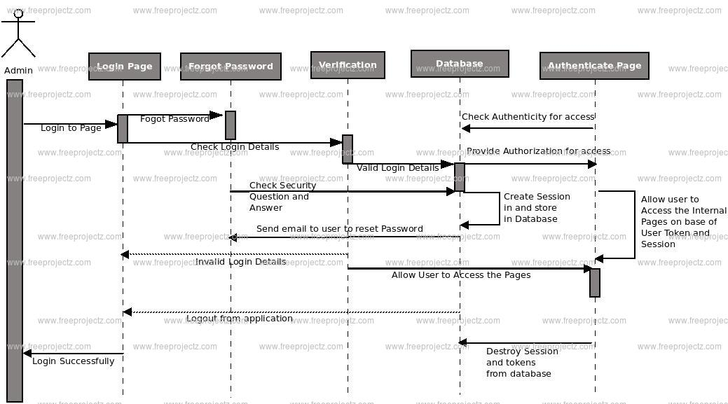

**5.6 ACTIVITY DIAGRAM**

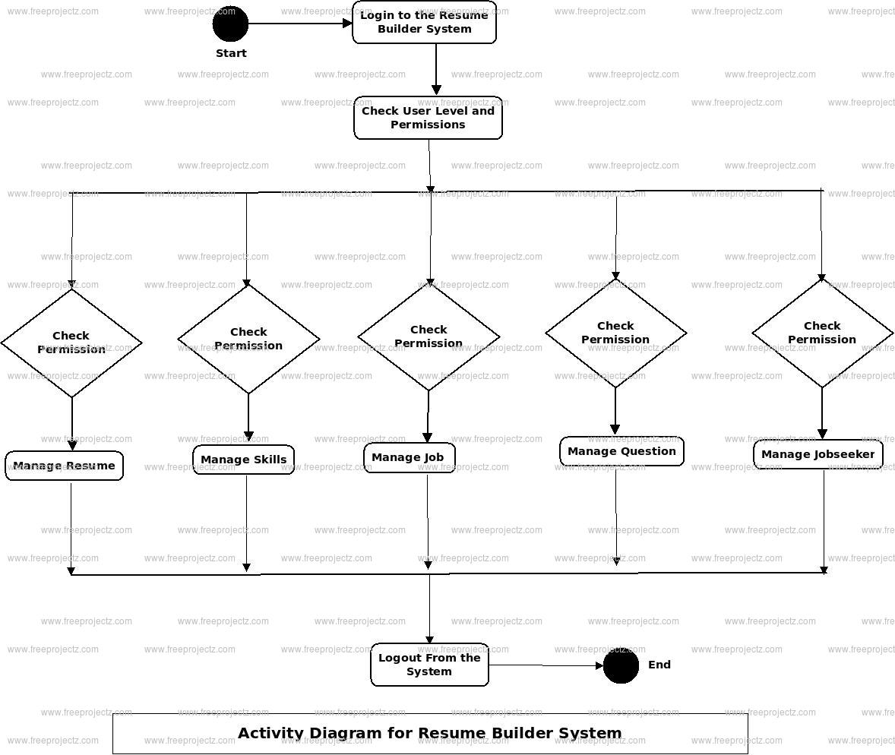

#### CHAPTER 6

#### GUI

**Modules Screenshots**

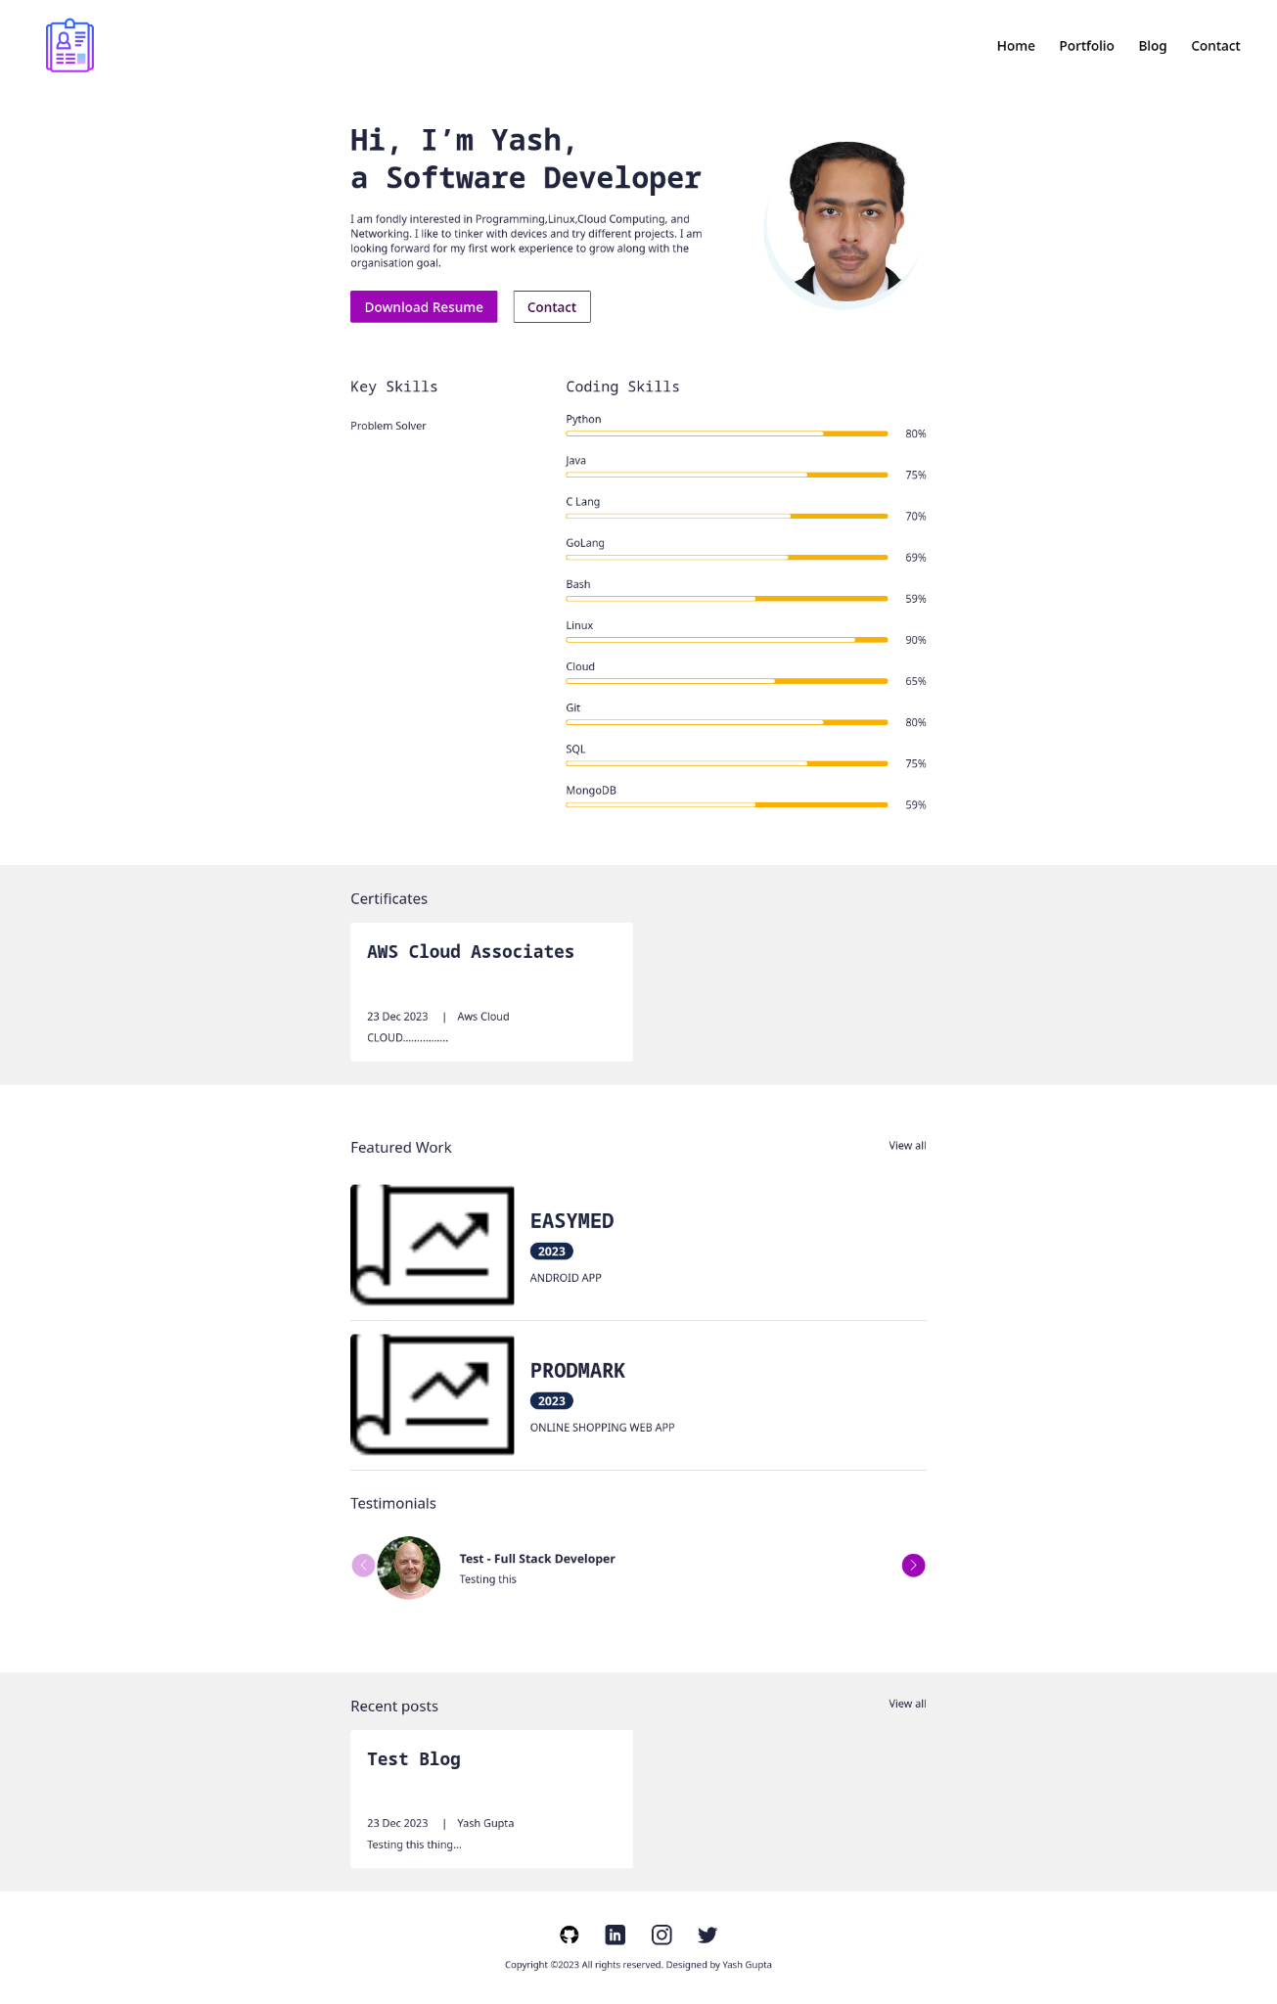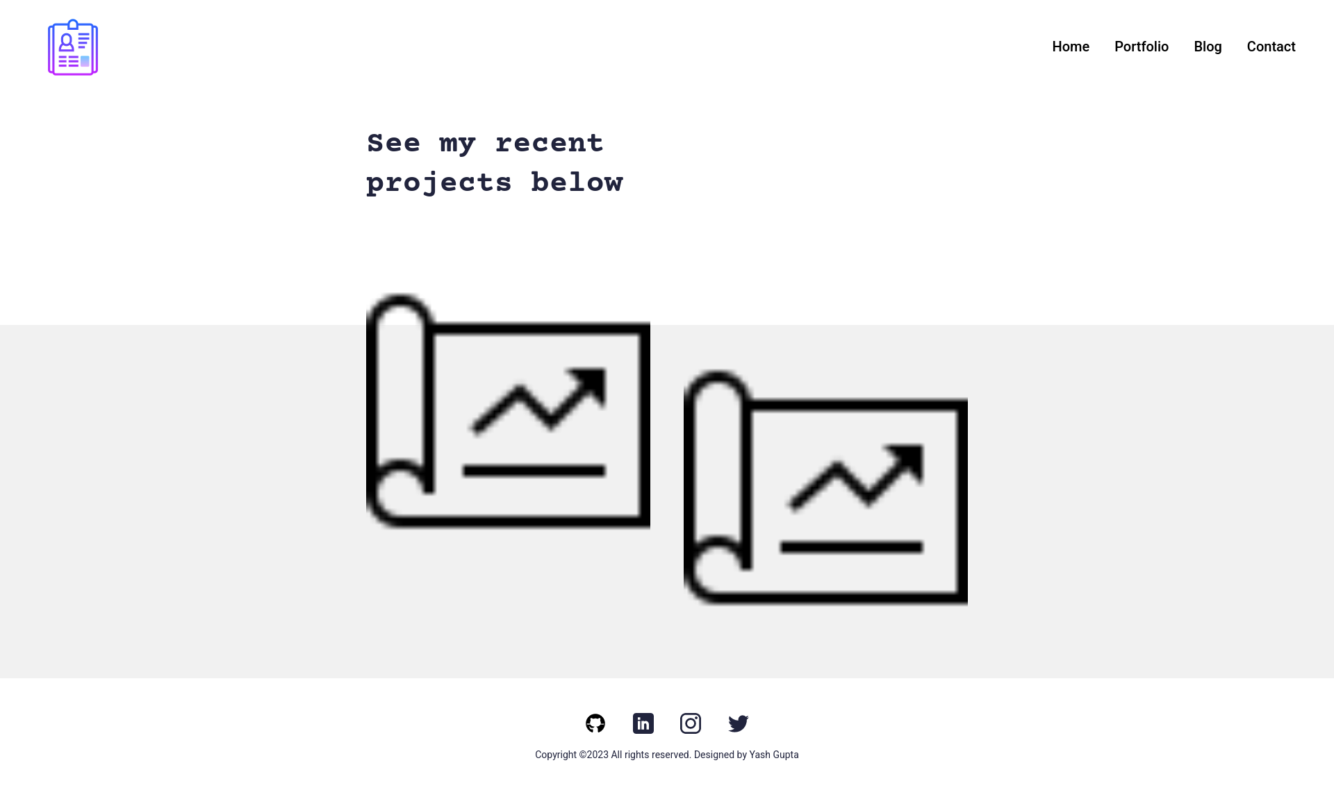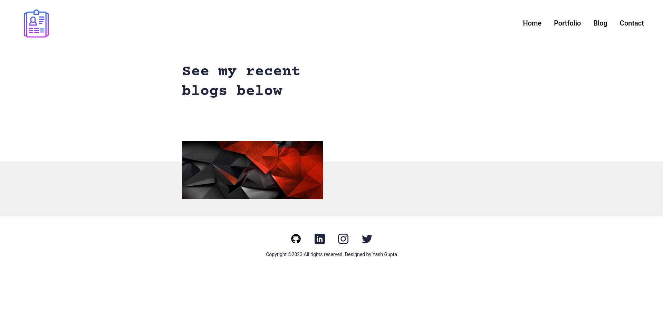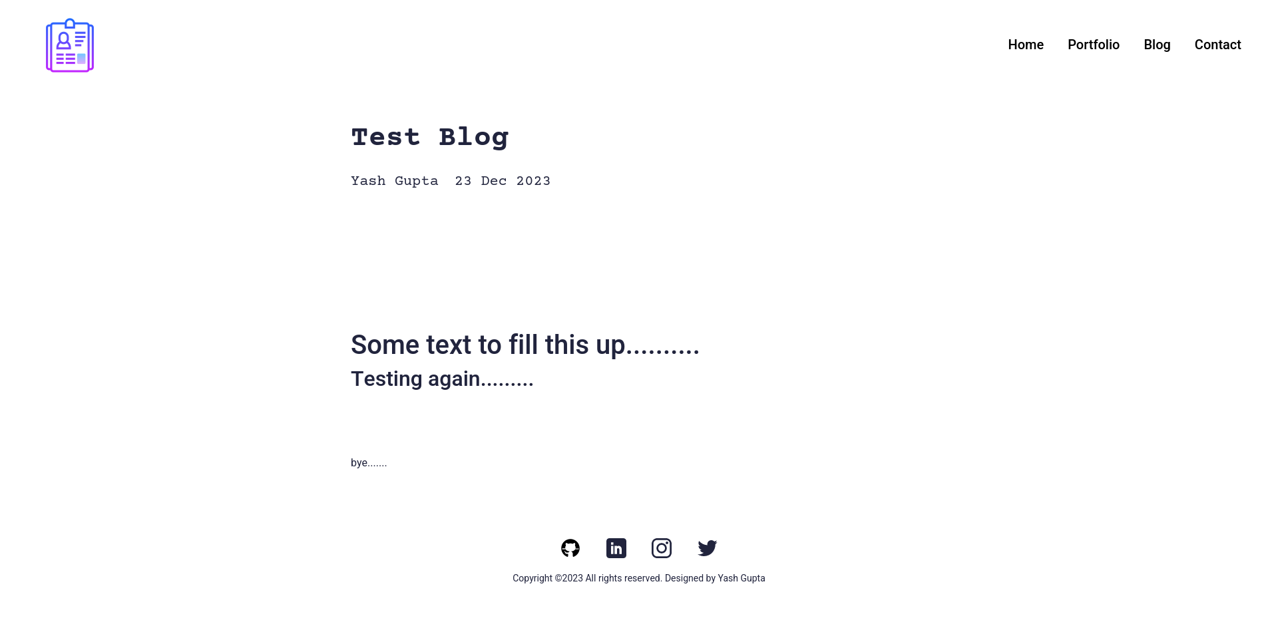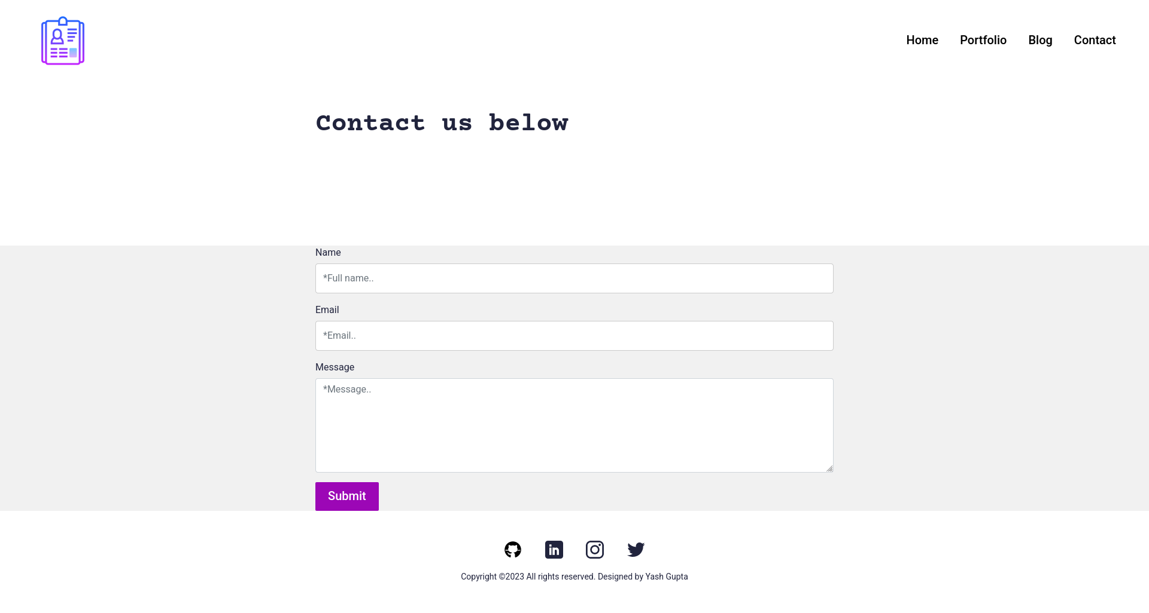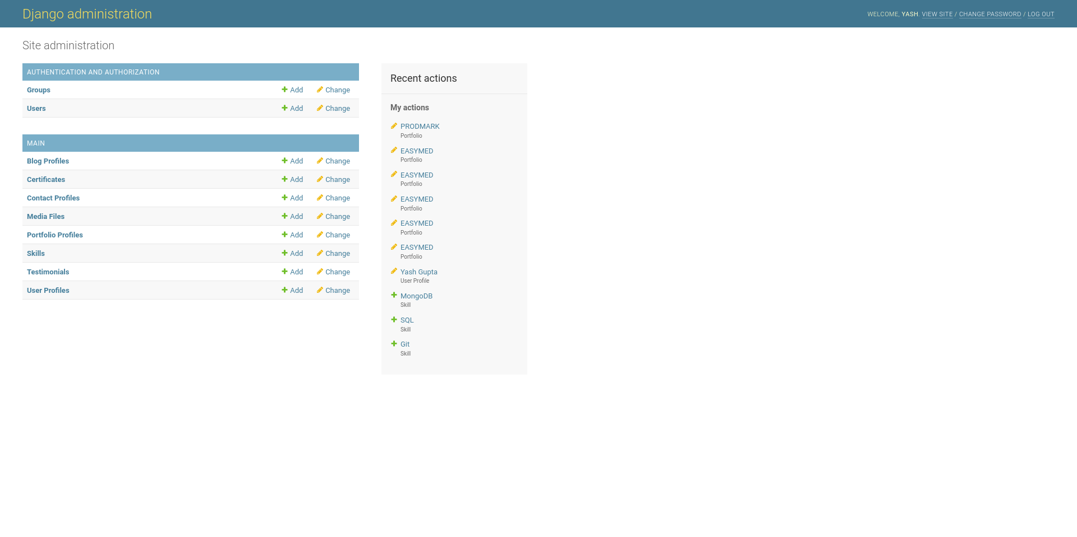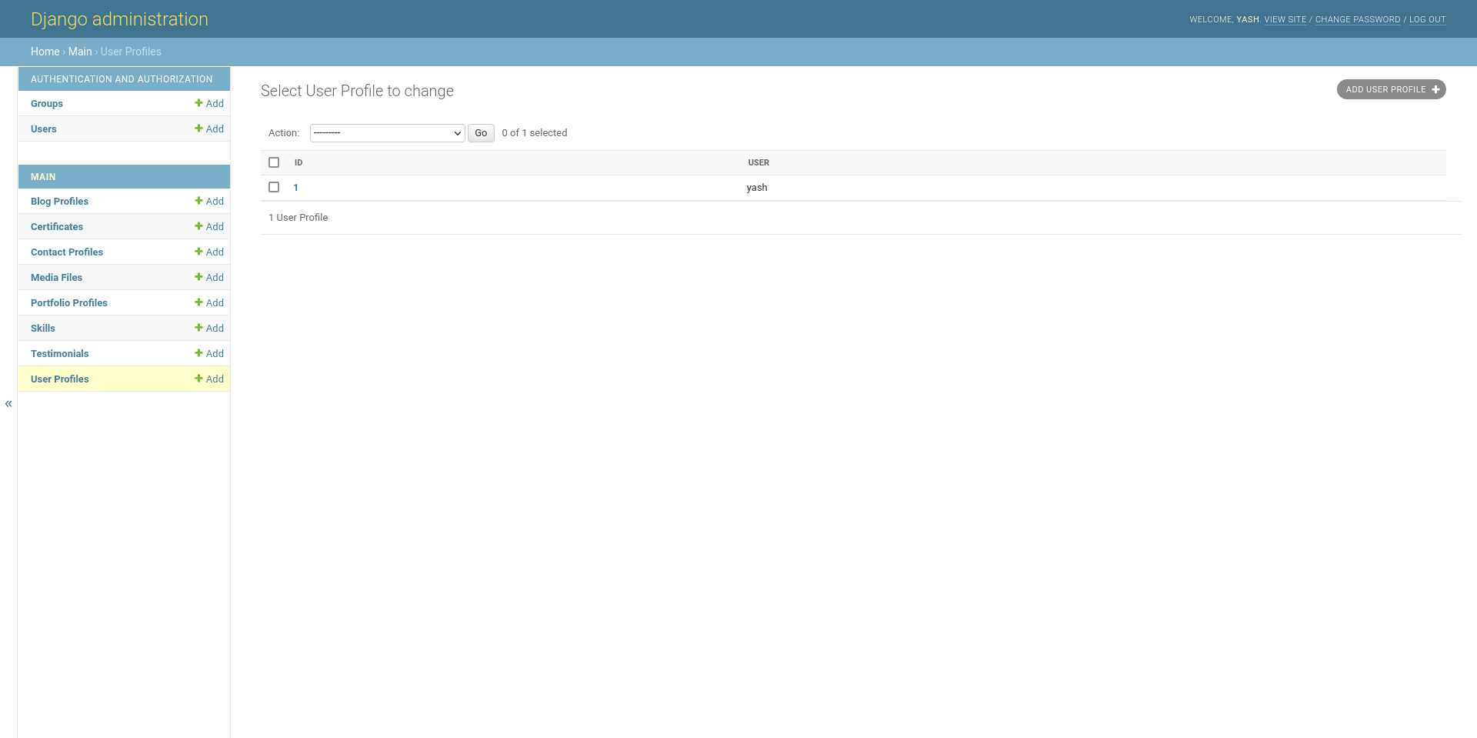

#### CODING

#### **HTML**

#### Base.html

#### {% load static %}

#### <!doctype html>

#### <html lang="en">

#### <head>

#### <meta charset="utf-8">

#### <meta name="viewport" content="width=device-width, initial-scale=1">

#### <title>{% block title %}{%endblock %}</title>

#### <meta name="author" content="Did Coding Limited & James Granger Design">

#### <link rel="canonical" href="{{request.path}}"/>

#### <link rel="home" href="{% url 'main:home' %}"/>

#### <meta name="description" content="{% block description %}{% endblock %}">

#### <meta name="keywords" content="{% block keywords %}{% endblock %}">

#### <link rel="shortcut icon" type="image/x-icon" href="{% static 'images/icon.jpg' %}">

#### <link rel="apple-touch-icon" type="image/jpg" href="{% static 'images/icon.jpg' %}">

#### <!-- ================================

#### Start CSS

#### ================================= -->

#### <link href="{% static 'css/bootstrap.min.css' %}" rel="stylesheet">

#### <link rel="stylesheet" href="https://unpkg.com/swiper@7.0.5/swiper-bundle.min.css">

#### <link href="{% static 'css/style.css' %}" rel="stylesheet">

#### {% block extend_header%}{%endblock%}

#### <!-- ================================

#### End CSS

#### ================================= -->

#### </head>

#### <body>

#### {% include 'main/partials/messages.html' %}

#### {% include 'main/partials/nav.html' %}

#### {% block content %}

#### {% endblock %}

#### {% include 'main/partials/footer.html' %}

#### <!-- ================================

#### Start Scripts

#### ================================= -->

#### <script src="https://cdnjs.cloudflare.com/ajax/libs/jquery/3.6.0/jquery.min.js"></script>

#### <script src="{% static 'js/bootstrap.bundle.min.js' %}"></script>

#### <script src="https://unpkg.com/swiper@7.0.5/swiper-bundle.min.js"></script>

#### <script src="{% static 'js/script.js' %}"></script>

#### {% block extend_footer %}{%endblock%}

#### <!-- ================================

#### End Scripts

#### ================================= -->

#### </body>

#### </html>

#### **Blog.html**

#### {% extends 'main/base.html' %}

#### {% load static %}

#### <!-- ================================

#### Start SEO blocks

#### ================================= -->

#### {% block title %}{% endblock %}

#### {% block decription %}{% endblock %}

#### {% block keywords %}{% endblock %}

#### <!-- ================================

#### END SEO blocks

#### ================================= -->

#### <!-- ================================

#### Start CSS blocks

#### ================================= -->

#### {% block extend_header %}{% endblock %}

#### <!-- ================================

#### END CSS blocks

#### ================================= -->

#### <!-- ================================

#### Start script blocks

#### ================================= -->

#### {% block extend_footer %}{% endblock %}

#### <!-- ================================

#### END script blocks

#### ================================= -->

#### <!-- ================================

#### Start Content

#### ================================= -->

#### {% block content %}

#### <section>

#### <div class="innerPageBannerCol">

#### <div class="container">

#### <div class="row g-4 g-md-3 align-items-center">

#### <div class="col-md-6">

#### <div class="bannerContent">

#### <h1 class="xlTitle pb-md-3">See my recent blogs below</h1>

#### </div>

#### </div>

#### </div>

#### </div>

#### </div>

#### </section>

#### <section>

#### <div class="lightBg">

#### <div class="container">

#### <div class="portfolioContentMain">

#### <div class="row g-3 g-md-4 g-lg-5 portfolioRow">

#### {% for obj in object_list %}

#### <div class="col-md-6 pColMain">

#### <div class="pCol">

#### <a href="{% url 'main:blog' slug=obj.slug %}" >

#### <img src="{{obj.image.url}}" alt="..." class="pImg">

#### </a>

#### </div>

#### </div>

#### {% endfor %}

#### </div>

#### </div>

#### </div>

#### </div>

#### </section>

#### <!-- ================================

#### End Content

#### ================================= -->

#### {%endblock%}

#### 

#### **Portfolio.html**

#### {% extends 'main/base.html' %}

#### {% load static %}

#### <!-- ================================

#### Start SEO blocks

#### ================================= -->

#### {% block title %}{% endblock %}

#### {% block decription %}{% endblock %}

#### {% block keywords %}{% endblock %}

#### <!-- ================================

#### END SEO blocks

#### ================================= -->

#### <!-- ================================

#### Start CSS blocks

#### ================================= -->

#### {% block extend_header %}{% endblock %}

#### <!-- ================================

#### END CSS blocks

#### ================================= -->

#### <!-- ================================

#### Start script blocks

#### ================================= -->

#### {% block extend_footer %}{% endblock %}

#### <!-- ================================

#### END script blocks

#### ================================= -->

#### <!-- ================================

#### Start Content

#### ================================= -->

#### {% block content %}

#### <section>

#### <div class="innerPageBannerCol">

#### <div class="container">

#### <div class="row g-4 g-md-3 align-items-center">

#### <div class="col-md-6">

#### <div class="bannerContent">

#### <h1 class="xlTitle pb-md-3">See my recent projects below</h1>

#### </div>

#### </div>

#### </div>

#### </div>

#### </div>

#### </section>

#### <section>

#### <div class="lightBg">

#### <div class="container">

#### <div class="portfolioContentMain">

#### <div class="row g-3 g-md-4 g-lg-5 portfolioRow">

#### {% for obj in object_list %}

#### <div class="col-md-6 pColMain">

#### <div class="pCol">

#### <a href="{% url 'main:portfolio' slug=obj.slug %}" >

#### <img src="{{obj.image.url}}" alt="..." class="pImg" >

#### </a>

#### </div>

#### </div>

#### {% endfor %}

#### 

#### </div>

#### </div>

#### </div>

#### </div>

#### </section>

#### <!-- ================================

#### End Content

#### ================================= -->

#### {% endblock%}

#### **Base.html**

#### {% load static %}

#### <!doctype html>

#### <html lang="en">

#### <head>

#### <meta charset="utf-8">

#### <meta name="viewport" content="width=device-width, initial-scale=1">

#### <title>{% block title %}{%endblock %}</title>

#### <meta name="author" content="Did Coding Limited & James Granger Design">

#### <link rel="canonical" href="{{request.path}}"/>

#### <link rel="home" href="{% url 'main:home' %}"/>

#### <meta name="description" content="{% block description %}{% endblock %}">

#### <meta name="keywords" content="{% block keywords %}{% endblock %}">

#### <link rel="shortcut icon" type="image/x-icon" href="{% static 'images/icon.jpg' %}">

#### <link rel="apple-touch-icon" type="image/jpg" href="{% static 'images/icon.jpg' %}">

#### <!-- ================================

#### Start CSS

#### ================================= -->

#### <link href="{% static 'css/bootstrap.min.css' %}" rel="stylesheet">

#### <link rel="stylesheet" href="https://unpkg.com/swiper@7.0.5/swiper-bundle.min.css">

#### <link href="{% static 'css/style.css' %}" rel="stylesheet">

#### {% block extend_header%}{%endblock%}

#### <!-- ================================

#### End CSS

#### ================================= -->

#### </head>

#### <body>

#### {% include 'main/partials/messages.html' %}

#### {% include 'main/partials/nav.html' %}

#### {% block content %}

#### {% endblock %}

#### 

#### {% include 'main/partials/footer.html' %}

#### 

#### <!-- ================================

#### Start Scripts

#### ================================= -->

#### <script src="https://cdnjs.cloudflare.com/ajax/libs/jquery/3.6.0/jquery.min.js"></script>

#### <script src="{% static 'js/bootstrap.bundle.min.js' %}"></script>

#### <script src="https://unpkg.com/swiper@7.0.5/swiper-bundle.min.js"></script>

#### <script src="{% static 'js/script.js' %}"></script>

#### {% block extend_footer %}{%endblock%}

#### <!-- ================================

#### End Scripts

#### ================================= -->

#### </body>

#### </html>

#### **Nav.html**

#### {% load static %}

#### <!-- ================================

#### Start Navigation Bar

#### ================================= -->

#### <header>

#### <div class="headerCol">

#### <div class="container-fluid">

#### <div class="row align-items-center">

#### <div class="col-auto">

#### <div class="logoCol"><a href="{% url 'main:home' %}"><img src="{% static 'images/icons8-resume-100.png' %}" alt="..."></a></div>

#### </div>

#### <div class="col">

#### <div class="d-md-none">

#### <button class="navToggle">

#### <span class="navToggle__text">Toggle Menu</span>

#### </button>

#### </div>

#### <div class="navCollapseCol">

#### <div class="navCol">

#### <ul>

#### <li><a href="{%url 'main:home'%}">Home</a></li>

#### <li><a href="{%url 'main:portfolios' %}">Portfolio</a></li>

#### <li><a href="{% url 'main:blogs' %}">Blog</a></li>

#### <li><a href="{%url 'main:contact'%}">Contact</a></li>

#### </ul>

#### </div>

#### </div>

#### </div>

#### </div>

#### </div>

#### </div>

#### </header>

#### <!-- ================================

#### End Navigation Bar

#### ================================= -->

#### **Footer.html**

#### {% load static %}

#### <!-- ================================

#### Start Footer

#### ================================= -->

#### <footer>

#### <div class="footerCol">

#### <div class="container">

#### <ul class="socialCol">

#### <li><a href="https://github.com/techyyash/"><img src="{% static 'images/github.svg' %}" alt="..."></a></li>

#### <li><a href="https://www.linkedin.com/in/yash-gupta-03573a119/"><img src="{% static 'images/linkedin.svg' %}" alt="..."></a></li>

#### <li><a href="https://instagram.com"><img src="{% static 'images/insta.svg' %}" alt="..."></a></li>

#### <li><a href="https://twitter.com"><img src="{% static 'images/twitter.svg' %}" alt="..."></a></li>

#### </ul>

#### <div class="copyrightCol">

#### <p>Copyright ©{% now 'Y' %} All rights reserved. Designed by <a href="https://github.com/techyyash/" target="_blank">Yash Gupta</a></p>

#### </div>

#### </div>

#### </div>

#### </footer>

#### <!-- ================================

#### End Footer

#### ================================= -->

#### **0001_initial.py**

#### import ckeditor.fields

#### from django.conf import settings

#### from django.db import migrations, models

#### import django.db.models.deletion

#### class Migration(migrations.Migration):

#### initial = True

#### dependencies = [

#### migrations.swappable_dependency(settings.AUTH_USER_MODEL),

#### ]

#### operations = [

#### migrations.CreateModel(

#### name='Certificate',

#### fields=[

#### ('id', models.BigAutoField(auto_created=True, primary_key=True, serialize=False, verbose_name='ID')),

#### ('date', models.DateTimeField(blank=True, null=True)),

#### ('name', models.CharField(blank=True, max_length=50, null=True)),

#### ('title', models.CharField(blank=True, max_length=200, null=True)),

#### ('description', models.CharField(blank=True, max_length=500, null=True)),

#### ],

#### options={

#### 'verbose_name': 'Certificate',

#### 'verbose_name_plural': 'Certificates',

#### },

#### ),

#### migrations.CreateModel(

#### name='ContactProfile',

#### fields=[

#### ('id', models.BigAutoField(auto_created=True, primary_key=True, serialize=False, verbose_name='ID')),

#### ('timestamp', models.DateTimeField(auto_now_add=True)),

#### ('name', models.CharField(max_length=100, verbose_name='Name')),

#### ('email', models.EmailField(max_length=254, verbose_name='Email')),

#### ('message', models.TextField(verbose_name='Message')),

#### ],

#### options={

#### 'verbose_name': 'Contact Profile',

#### 'verbose_name_plural': 'Contact Profiles',

#### 'ordering': ['timestamp'],

#### },

#### ),

#### migrations.CreateModel(

#### name='Media',

#### fields=[

#### ('id', models.BigAutoField(auto_created=True, primary_key=True, serialize=False, verbose_name='ID')),

#### ('image', models.ImageField(blank=True, null=True, upload_to='media')),

#### ('url', models.URLField(blank=True, null=True)),

#### ('name', models.CharField(blank=True, max_length=200, null=True)),

#### ('is_image', models.BooleanField(default=True)),

#### ],

#### options={

#### 'verbose_name': 'Media',

#### 'verbose_name_plural': 'Media Files',

#### 'ordering': ['name'],

#### },

#### ),

#### migrations.CreateModel(

#### name='Skill',

#### fields=[

#### ('id', models.BigAutoField(auto_created=True, primary_key=True, serialize=False, verbose_name='ID')),

#### ('name', models.CharField(blank=True, max_length=20, null=True)),

#### ('score', models.IntegerField(blank=True, default=80, null=True)),

#### ],

#### options={

#### 'verbose_name': 'Skill',

#### 'verbose_name_plural': 'Skills',

#### },

#### ),

#### migrations.CreateModel(

#### name='TagProfile',

#### fields=[

#### ('id', models.BigAutoField(auto_created=True, primary_key=True, serialize=False, verbose_name='ID')),

#### ('name', models.CharField(blank=True, max_length=20, null=True)),

#### ],

#### options={

#### 'verbose_name': 'Tag',

#### 'verbose_name_plural': 'Tags',

#### },

#### ),

#### migrations.CreateModel(

#### name='Testimonial',

#### fields=[

#### ('id', models.BigAutoField(auto_created=True, primary_key=True, serialize=False, verbose_name='ID')),

#### ('thumbnail', models.ImageField(blank=True, null=True, upload_to='')),

#### ('name', models.CharField(blank=True, max_length=200, null=True)),

#### ('role', models.CharField(blank=True, max_length=200, null=True)),

#### ('quote', models.CharField(blank=True, max_length=500, null=True)),

#### ],

#### options={

#### 'verbose_name': 'Testimonial',

#### 'verbose_name_plural': 'Testimonials',

#### 'ordering': ['name'],

#### },

#### ),

#### migrations.CreateModel(

#### name='TypeProfile',

#### fields=[

#### ('id', models.BigAutoField(auto_created=True, primary_key=True, serialize=False, verbose_name='ID')),

#### ('name', models.CharField(blank=True, max_length=20, null=True)),

#### ],

#### options={

#### 'verbose_name': 'Type Profiles',

#### 'verbose_name_plural': 'Type Profiles',

#### },

#### ),

#### migrations.CreateModel(

#### name='UserProfile',

#### fields=[

#### ('id', models.BigAutoField(auto_created=True, primary_key=True, serialize=False, verbose_name='ID')),

#### ('title', models.CharField(blank=True, max_length=200, null=True)),

#### ('bio', models.TextField(blank=True, null=True)),

#### ('cv', models.FileField(blank=True, null=True, upload_to='cv')),

#### ('skills', models.ManyToManyField(blank=True, to='main.Skill')),

#### ('user', models.OneToOneField(on_delete=django.db.models.deletion.CASCADE, to=settings.AUTH_USER_MODEL)),

#### ],

#### options={

#### 'verbose_name': 'User Profile',

#### 'verbose_name_plural': 'User Profiles',

#### },

#### ),

#### migrations.CreateModel(

#### name='Portfolio',

#### fields=[

#### ('id', models.BigAutoField(auto_created=True, primary_key=True, serialize=False, verbose_name='ID')),

#### ('name', models.CharField(blank=True, max_length=200, null=True)),

#### ('description', models.CharField(blank=True, max_length=500, null=True)),

#### ('body', ckeditor.fields.RichTextField(blank=True, null=True)),

#### ('image', models.ImageField(blank=True, null=True, upload_to='portfolio')),

#### ('slug', models.SlugField(blank=True, null=True)),

#### ('portfolio_tags', models.ManyToManyField(blank=True, to='main.TagProfile')),

#### ('portfolio_types', models.ManyToManyField(blank=True, to='main.TypeProfile')),

#### ],

#### options={

#### 'verbose_name': 'Portfolio',

#### 'verbose_name_plural': 'Portfolio Profiles',

#### 'ordering': ['name'],

#### },

#### ),

#### migrations.CreateModel(

#### name='Blog',

#### fields=[

#### ('id', models.BigAutoField(auto_created=True, primary_key=True, serialize=False, verbose_name='ID')),

#### ('timestamp', models.DateTimeField(auto_now_add=True)),

#### ('author', models.CharField(blank=True, max_length=200, null=True)),

#### ('name', models.CharField(blank=True, max_length=200, null=True)),

#### ('description', models.CharField(blank=True, max_length=500, null=True)),

#### ('body', ckeditor.fields.RichTextField(blank=True, null=True)),

#### ('slug', models.SlugField(blank=True, null=True)),

#### ('image', models.ImageField(blank=True, null=True, upload_to='blog')),

#### ('blog_tags', models.ManyToManyField(blank=True, to='main.TagProfile')),

#### ('blog_types', models.ManyToManyField(blank=True, to='main.TypeProfile')),

#### ],

#### options={

#### 'verbose_name': 'Blog',

#### 'verbose_name_plural': 'Blog Profiles',

#### 'ordering': ['timestamp'],

#### },

#### ),

#### ]

#### **Python**

#### **Urls.py**

#### from django.contrib import admin

#### from django.urls import path, include

#### from django.conf import settings

#### from django.conf.urls.static import static

#### from django.views.static import serve

#### from django.conf.urls import url

#### urlpatterns = [

#### path('admin/', admin.site.urls),

#### path('', include('main.urls', namespace="main")),

#### url(r'^media/(?P<path>.*)$', serve,

#### {'document_root': settings.MEDIA_ROOT}),

#### url(r'^static/(?P<path>.*)$', serve,

#### {'document_root': settings.STATIC_ROOT}),

#### ]

#### if settings.DEBUG:

#### urlpatterns += static(settings.STATIC_URL, document_root=settings.STATIC_ROOT)

#### urlpatterns += static(settings.MEDIA_URL, document_root=settings.MEDIA_ROOT)

#### **admin.py**

#### from django.contrib import admin

#### from . models import (

#### UserProfile,

#### ContactProfile,

#### Testimonial,

#### Media,

#### Portfolio,

#### Blog,

#### Certificate,

#### Skill

#### )

#### @admin.register(UserProfile)

#### class UserProfileAdmin(admin.ModelAdmin):

#### list_display = ('id', 'user')

#### @admin.register(ContactProfile)

#### class ContactAdmin(admin.ModelAdmin):

#### list_display = ('id', 'timestamp', 'name',)

#### @admin.register(Testimonial)

#### class TestimonialAdmin(admin.ModelAdmin):

#### list_display = ('id','name','is_active')

#### @admin.register(Media)

#### class MediaAdmin(admin.ModelAdmin):

#### list_display = ('id', 'name')

#### @admin.register(Portfolio)

#### class PortfolioAdmin(admin.ModelAdmin):

#### list_display = ('id','name','is_active')

#### readonly_fields = ('slug',)

#### @admin.register(Blog)

#### class BlogAdmin(admin.ModelAdmin):

#### list_display = ('id','name','is_active')

#### readonly_fields = ('slug',)

#### @admin.register(Certificate)

#### class CertificateAdmin(admin.ModelAdmin):

#### list_display = ('id','name')

#### 

#### @admin.register(Skill)

#### class SkillAdmin(admin.ModelAdmin):

#### list_display = ('id','name','score')

**views.py**

from django.shortcuts import render

from django.contrib import messages

from .models import (

UserProfile,

Blog,

Portfolio,

Testimonial,

Certificate

)

from django.views import generic

from . forms import ContactForm

class IndexView(generic.TemplateView):

template_name = "main/index.html"

def get_context_data(self, **kwargs):

context = super().get_context_data(**kwargs)

testimonials = Testimonial.objects.filter(is_active=True)

certificates = Certificate.objects.filter(is_active=True)

blogs = Blog.objects.filter(is_active=True)

portfolio = Portfolio.objects.filter(is_active=True)

context["testimonials"] = testimonials

context["certificates"] = certificates

context["blogs"] = blogs

context["portfolio"] = portfolio

return context

class ContactView(generic.FormView):

template_name = "main/contact.html"

form_class = ContactForm

success_url = "/"

def form_valid(self, form):

form.save()

messages.success(self.request, 'Thank you. We will be in touch soon.')

return super().form_valid(form)

class PortfolioView(generic.ListView):

model = Portfolio

template_name = "main/portfolio.html"

paginate_by = 10

def get_queryset(self):

return super().get_queryset().filter(is_active=True)

class PortfolioDetailView(generic.DetailView):

model = Portfolio

template_name = "main/portfolio-detail.html"

class BlogView(generic.ListView):

model = Blog

template_name = "main/blog.html"

paginate_by = 10

def get_queryset(self):

return super().get_queryset().filter(is_active=True)

class BlogDetailView(generic.DetailView):

model = Blog

template_name = "main/blog-detail.html"

**models.py**

from django.db import models

from django.contrib.auth.models import User

from django.template.defaultfilters import slugify

from ckeditor.fields import RichTextField

class Skill(models.Model):

class Meta:

verbose_name_plural = 'Skills'

verbose_name = 'Skill'

name = models.CharField(max_length=20, blank=True, null=True)

score = models.IntegerField(default=80, blank=True, null=True)

image = models.FileField(blank=True, null=True, upload_to="skills")

is_key_skill = models.BooleanField(default=False)

def __str__(self):

return self.name

class UserProfile(models.Model):

class Meta:

verbose_name_plural = 'User Profiles'

verbose_name = 'User Profile'

user = models.OneToOneField(User, on_delete=models.CASCADE)

avatar = models.ImageField(blank=True, null=True, upload_to="avatar")

title = models.CharField(max_length=200, blank=True, null=True)

bio = models.TextField(blank=True, null=True)

skills = models.ManyToManyField(Skill, blank=True)

cv = models.FileField(blank=True, null=True, upload_to="cv")

def __str__(self):

return f'{self.user.first_name} {self.user.last_name}'

class ContactProfile(models.Model):

class Meta:

verbose_name_plural = 'Contact Profiles'

verbose_name = 'Contact Profile'

ordering = ["timestamp"]

timestamp = models.DateTimeField(auto_now_add=True)

name = models.CharField(verbose_name="Name",max_length=100)

email = models.EmailField(verbose_name="Email")

message = models.TextField(verbose_name="Message")

def __str__(self):

return f'{self.name}'

class Testimonial(models.Model):

class Meta:

verbose_name_plural = 'Testimonials'

verbose_name = 'Testimonial'

ordering = ["name"]

thumbnail = models.ImageField(blank=True, null=True, upload_to="testimonials")

name = models.CharField(max_length=200, blank=True, null=True)

role = models.CharField(max_length=200, blank=True, null=True)

quote = models.CharField(max_length=500, blank=True, null=True)

is_active = models.BooleanField(default=True)

def __str__(self):

return self.name

class Media(models.Model):

class Meta:

verbose_name_plural = 'Media Files'

verbose_name = 'Media'

ordering = ["name"]

image = models.ImageField(blank=True, null=True, upload_to="media")

url = models.URLField(blank=True, null=True)

name = models.CharField(max_length=200, blank=True, null=True)

is_image = models.BooleanField(default=True)

def save(self, *args, **kwargs):

if self.url:

self.is_image = False

super(Media, self).save(*args, **kwargs)

def __str__(self):

return self.name

class Portfolio(models.Model):

class Meta:

verbose_name_plural = 'Portfolio Profiles'

verbose_name = 'Portfolio'

ordering = ["name"]

date = models.DateTimeField(blank=True, null=True)

name = models.CharField(max_length=200, blank=True, null=True)

description = models.CharField(max_length=500, blank=True, null=True)

body = RichTextField(blank=True, null=True)

image = models.ImageField(blank=True, null=True, upload_to="portfolio")

slug = models.SlugField(null=True, blank=True)

is_active = models.BooleanField(default=True)

def save(self, *args, **kwargs):

if not self.id:

self.slug = slugify(self.name)

super(Portfolio, self).save(*args, **kwargs)

def __str__(self):

return self.name

def get_absolute_url(self):

return f"/portfolio/{self.slug}"

class Blog(models.Model):

class Meta:

verbose_name_plural = 'Blog Profiles'

verbose_name = 'Blog'

ordering = ["timestamp"]

timestamp = models.DateTimeField(auto_now_add=True)

author = models.CharField(max_length=200, blank=True, null=True)

name = models.CharField(max_length=200, blank=True, null=True)

description = models.CharField(max_length=500, blank=True, null=True)

body = RichTextField(blank=True, null=True)

slug = models.SlugField(null=True, blank=True)

image = models.ImageField(blank=True, null=True, upload_to="blog")

is_active = models.BooleanField(default=True)

def save(self, *args, **kwargs):

if not self.id:

self.slug = slugify(self.name)

super(Blog, self).save(*args, **kwargs)

def __str__(self):

return self.name

def get_absolute_url(self):

return f"/blog/{self.slug}"

class Certificate(models.Model):

class Meta:

verbose_name_plural = 'Certificates'

verbose_name = 'Certificate'

date = models.DateTimeField(blank=True, null=True)

name = models.CharField(max_length=50, blank=True, null=True)

title = models.CharField(max_length=200, blank=True, null=True)

description = models.CharField(max_length=500, blank=True, null=True)

is_active = models.BooleanField(default=True)

def __str__(self):

return self.name

#### CHAPTER 7

#### TESTING

#### (TEST PLAN/CASES/RESULT)

#### 7.1 Test Plan

#### A comprehensive test plan is crucial to ensure the reliability and functionality of

#### DRESUME. The test plan outlines the testing strategy, objectives, scope, and

#### resources required for testing. It includes various types of testing such as unit

#### testing, integration testing, system testing, and user acceptance testing (UAT). The

#### objectives of the test plan are to verify that all functionalities work as intended,

#### identify and fix any bugs or issues, ensure compatibility across different devices and

#### browsers, and validate the overall user experience. The scope of testing covers all

#### features and functionalities of DRESUME, including user authentication, property

#### listings, search and filtering, messaging system, and user dashboard. The resources

#### required for testing include testing tools, devices, and personnel responsible for

#### conducting and documenting the tests.

#### 7.2 Test Cases

#### Test cases are detailed descriptions of specific scenarios and inputs to be tested,

#### along with expected outcomes and actual results. Each test case covers a particular

#### aspect or functionality of DRESUME and includes steps to execute the test, input

#### data, expected results, and actual results observed during testing. For example, a

#### test case for user authentication would include steps to register a new user, input

#### valid credentials for login, and verify that the user is successfully logged in. Test

#### cases are designed to validate the correctness and robustness of DRESUME and

#### ensure that it meets the specified requirements and user expectations.

#### 7.3 Test Results

#### After executing the test cases, the results of testing are documented and

#### summarized. This includes a summary of the testing outcomes, highlighting any

#### issues or defects encountered during testing, such as bugs, errors, or

#### inconsistencies. The test results also include details of any successful tests and

#### 59confirmation that the functionalities work as intended. Additionally, any deviations

#### from the expected results are noted, along with the steps taken to address them.

#### 7.4 Issues and Resolutions

#### This section provides a detailed discussion of significant issues encountered during

#### testing and the steps taken to resolve them. It includes descriptions of the issues

#### identified, their root causes, and the actions taken to fix them. Additionally, it may

#### include discussions on any challenges faced during testing, such as compatibility

#### issues, performance issues, or usability issues, and the strategies employed to

#### overcome them

### CHAPTER 8

### CONCLUSION

**8.2 PROJECT LIMITATION**

Despite the successful development of DRESUME, there may be certain limitations

encountered during the project. These limitations could include technical constraints,

such as limitations of the chosen technologies or frameworks, resource limitations,

such as budget or time constraints, or scope changes that may have affected the

project deliverables. It is essential to acknowledge these limitations to provide a

realistic assessment of the project's achievements and to identify areas for

improvement in future projects.

### 8.2 FUTURE SCOPE

Online Resume Builder can be used in accordance with customer requirements. Customers can customize theirs resumes with a selection of topics and details. Services are It's hard to be beaten by competitors because the system is giving customers exactly what they want.

**CHAPTER 9**

### REFERENCES

* Wikipedia.org
* [www.w3schools.com](http://www.w3schools.com/)
* Software Engineering – R.S.Pressma
* JavaScript By McGraw hill Publication
* Youtube.com

